Source 1 – Herr Hitler thinks of a policy, 1933.

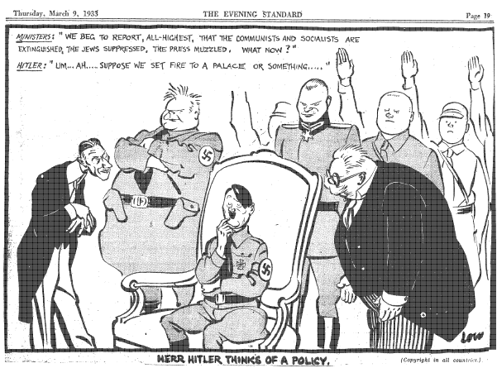

Cartoon by David Low published in The Evening Standard on Thursday March 9th 1933.

Source 2 – Alan Bullock, British Historian, on Hitler’s success:

Despite the mass support he had won, Hitler came to office in 1933 as a result, not of any irresistible revolutionary or national movement sweeping him into power, nor even of a popular victory at the polls, but as part of a shoddy political deal with the ‘Old Gang’ whom he had been attacking for months. Hitler did not seize power; he was jobbed into office by backstairs intrigue. Far from being inevitable, Hitler’s success owed much to luck and even more to the bad judgment of his political opponents and rivals… As Hitler freely admitted afterwards, the Party’s fortunes were at their lowest ebb when the unexpected intervention of Papen offered them a chance they could scarcely have foreseen.

Alan Bullock, Hitler: A Study In Tyranny, Penguin Books, London, 1962, p.253

Identify how, and discuss why, Sources 1 and 2 are contestable. (6 marks)

Marking key:

Description | Marks
Identifies the element/s of contestability for Sources 1 and 2 | 1–2
Discusses the reasons for the contestability of Source 1 | 1–2
Discusses the reasons for the contestability of Source 2 | 1–2
Total | 6
Note: The concept of contestability requires a discussion of conflicting historical interpretations represented in source material, specifically why they are different and open to debate.
Answers should:
- demonstrate an understanding of what can make a source contestable, whether it provides a certain interpretation of events for which other interpretations exist; or whether the source/s can be disputed as historical evidence
- identify in each source the argument/s, biases, motives or perspectives that can be disputed.
Stronger candidates may discuss the nature of the contestability, perhaps by referring to alternative arguments or viewpoints on the interpretations presented by the sources, or by making comparisons between the two sources.

__________________________________________________________________________________________________________________________________________________________________________________________________________________________________________________________________________________________________________________________________________________________________________________________________________________________________________________________________________________________________________________________________________________________________________________________________________________________________________________________________________________________________________________________________________________________________________________________________________________________________________________________________________________________________________________________________________________________________________________________________________________________________________________________________________________________________________________________________________________________________________________________________________________________________________________________________________________________________________________________________________________________________________________________________________________________________________________________________________________________________________________________________________________________________________________________________________________________________________________________________________________________________________________________________________________________________________________________________________________________________________________________________

Source 3

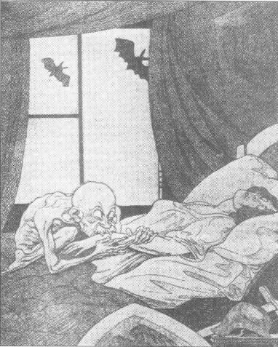

A cartoon with the title 'Clemenceau the Vampire'
from the German Newspaper, Kladderadatsch (July 1919)

The figure lying on the bed represents Germany.
Clemenceau was Prime Minister of France in 1919.
He is shown as a vampire sucking the blood out of Germany.

Source 4

November Criminals.
Many Germans did not want their new government to sign the peace settlement. They believed they had been stabbed in the back by the November Criminals – those who had agreed to end the fighting in November 1918. They were happy to believe their country had been betrayed by cowards or those whom many thought might be disloyal to the country, like the Jews. Once Hitler had got into power in 1933, this was an idea that he exploited to its most horrifying limits.

http://atschool.eduweb.co.uk/redschl/historydocs/Germany%201919-1939%20GCSE/Stab%20in%20back%20and%20the%20November%20Criminals..doc

Identify how, and discuss why, Sources 3 and 4 are contestable. (6 marks)

Marking key:

Description | Marks
Identifies the element/s of contestability for Sources 3 and 4 | 1–2
Discusses the reasons for the contestability of Source 3 | 1–2
Discusses the reasons for the contestability of Source 4 | 1–2
Total | 6
Note: The concept of contestability requires a discussion of conflicting historical interpretations represented in source material, specifically why they are different and open to debate.
Answers should:
- demonstrate an understanding of what can make a source contestable, whether it provides a certain interpretation of events for which other interpretations exist; or whether the source/s can be disputed as historical evidence
- identify in each source the argument/s, biases, motives or perspectives that can be disputed.
Stronger candidates may discuss the nature of the contestability, perhaps by referring to alternative arguments or viewpoints on the interpretations presented by the sources, or by making comparisons between the two sources.

__________________________________________________________________________________________________________________________________________________________________________________________________________________________________________________________________________________________________________________________________________________________________________________________________________________________________________________________________________________________________________________________________________________________________________________________________________________________________________________________________________________________________________________________________________________________________________________________________________________________________________________________________________________________________________________________________________________________________________________________________________________________________________________________________________________________________________________________________________________________________________________________________________________________________________________________________________________________________________________________________________________________________________________________________________________________________________________________________________________________________________________________________________________________________________________________________________________________________________________________________________________________________________________________________________________________________________________________________________________________________________________________________

